Aim: To learn the Basics of Machine Learning
IDE: Google Colab

Theory:
Machine learning is a subset of artificial intelligence in the field of computer science that often uses statistical techniques to give computers the ability to "learn" (i.e., progressively improve performance on a specific task) with data, without being explicitly programmed. In the past decade, machine learning has given us self-driving cars, practical speech recognition, effective web search, and a vastly improved understanding of the human genome.

Machine learning tasks
Machine learning tasks are typically classified into two broad categories, depending on whether there is a learning "signal" or "feedback" available to a learning system:
- Supervised learning: The computer is presented with example inputs and their desired outputs, given by a "teacher", and the goal is to learn a general rule that maps inputs to outputs. As special cases, the input signal can be only partially available, or restricted to special feedback:
- Semi-supervised learning: the computer is given only an incomplete training signal: a training set with some (often many) of the target outputs missing.
- Active learning: the computer can only obtain training labels for a limited set of instances (based on a budget), and also has to optimize its choice of objects to acquire labels for. When used interactively, these can be presented to the user for labeling.
- Reinforcement learning: training data (in form of rewards and punishments) is given only as feedback to the program's actions in a dynamic environment, such as driving a vehicle or playing a game against an opponent.
- Unsupervised learning: No labels are given to the learning algorithm, leaving it on its own to find structure in its input. Unsupervised learning can be a goal in itself (discovering hidden patterns in data) or a means towards an end (feature learning).

Machine learning applications
In classification, inputs are divided into two or more classes, and the learner must produce a model that assigns unseen inputs to one or more (multi-label classification) of these classes. This is typically tackled in a supervised manner. Spam filtering is an example of classification, where the inputs are email (or other) messages and the classes are "spam" and "not spam". In regression, also a supervised problem, the outputs are continuous rather than discrete.
In clustering, a set of inputs is to be divided into groups. Unlike in classification, the groups are not known beforehand, making this typically an unsupervised task. Density estimation finds the distribution of inputs in

some space. Dimensionality reduction simplifies inputs by mapping them into a lower- dimensional space. Topic modeling is a related problem, where a program is given a list of human language documents and is tasked with finding out which documents cover similar topics.

Machine learning Approaches
Decision tree learning: Decision tree learning uses a decision tree as a predictive model, which maps observations about an item to conclusions about the item's target value. Association rule learning Association rule learning is a method for discovering interesting relations between variables in large databases.

Artificial neural networks
An artificial neural network (ANN) learning algorithm, usually called "neural network" (NN), is a learning algorithm that is vaguely inspired by biological neural networks. Computations are structured in terms of an interconnected group of artificial neurons, processing information using a connectionist approach to computation. Modern neural networks are non-linear statistical data modeling tools. They are usually used to model complex relationships between inputs and outputs, to find patterns in data, or to capture the statistical structure in an unknown joint probability distribution between observed variables.

Deep learning
Falling hardware prices and the development of GPUs for personal use in the last few years have contributed to the development of the concept of deep learning which consists of multiple hidden layers in an artificial neural network. This approach tries to model the way the human brain processes light and sound into vision and hearing. Some successful applications of deep learning are computer vision and speech recognition.

Inductive logic programming
Inductive logic programming (ILP) is an approach to rule learning using logic programming as a uniform representation for input examples, background knowledge, and hypotheses. Given an encoding of the known background knowledge and a set of examples represented as a logical database of facts, an ILP system will derive a hypothesized logic program that entails all positive and no negative examples. Inductive programming is a related field that considers any kind of programming languages for representing hypotheses (and not only logic programming), such as functional programs.

Support vector machines
Support vector machines (SVMs) are a set of related supervised learning methods used for classification and regression. Given a set of training examples, each marked as belonging to one of two categories, an SVM training algorithm builds a model that predicts whether a new example falls into one category or the other.

Clustering
Cluster analysis is the assignment of a set of observations into subsets (called clusters) so that observations within the same cluster are similar according to some pre designated criterion or criteria, while observations drawn from different clusters are dissimilar. Different clustering techniques make different assumptions on the

structure of the data, often defined by some similarity metric and evaluated for example by internal compactness (similarity between members of the same cluster) and separation between different clusters. Other methods are based on estimated density and graph connectivity. Clustering is a method of unsupervised learning, and a common technique for statistical data analysis.

Bayesian networks
A Bayesian network, belief network or directed acyclic graphical model is a probabilistic graphical model that represents a set of random variables and their conditional independencies via a directed acyclic graph (DAG). For example, a Bayesian network could represent the probabilistic relationships between diseases and symptoms. Given symptoms, the network can be used to compute the probabilities of the presence of various diseases. Efficient algorithms exist that perform inference and learning.

Reinforcement learning
Reinforcement learning is concerned with how an agent ought to take actions in an environment so as to maximize some notion of long-term reward. Reinforcement learning algorithms attempt to find a policy that maps states of the world to the actions the agent ought to take in those states. Reinforcement learning differs from the supervised learning problem in that correct input/output pairs are never presented, nor sub-optimal actions explicitly corrected.

Similarity and metric learning
In this problem, the learning machine is given pairs of examples that are considered similar and pairs of less similar objects. It then needs to learn a similarity function (or a distance metric function) that can predict if new objects are similar. It is sometimes used in Recommendation systems.

Genetic algorithms
A genetic algorithm (GA) is a search heuristic that mimics the process of natural selection, and uses methods such as mutation and crossover to generate new genotype in the hope of finding good solutions to a given problem. In machine learning, genetic algorithms found some uses in the 1980s and 1990s. Conversely, machine learning techniques have been used to improve the performance of genetic and evolutionary algorithms.

Rule-based machine learning
Rule-based machine learning is a general term for any machine learning method that identifies, learns, or evolves "rules" to store, manipulate or apply, knowledge. The defining characteristic of a rule-based machine learner is the identification and utilization of a set of relational rules that collectively represent the knowledge captured by the system. This is in contrast to other machine learners that commonly identify a singular model that can be universally applied to any instance in order to make a prediction. Rule-based machine learning approaches include learning classifier systems, association rule learning, and artificial immune systems.

Feature selection approach
Feature selection is the process of selecting an optimal subset of relevant features for use in model construction. It is assumed the data contains some features that are either redundant or irrelevant, and can thus be removed to reduce calculation cost without incurring much loss of information. Common optimality criteria include accuracy, similarity and information measures.

Pre Lab Exercise:

Write 5 applications, that you encounter daily, where Machine Learning is used?

Email spam filtering (Gmail detecting spam mails)

Recommendation systems (Netflix, YouTube suggesting content)

Voice assistants (Google Assistant, Alexa, Siri)

Face recognition (phone unlock, social media tagging)

Online shopping recommendations (Amazon product suggestions)

What do you mean by Supervised Learning?

Supervised Learning is a type of machine learning where the model is trained using labeled data (input with correct output).

The algorithm learns the relationship between input and output to predict results for new data.

Example: Email spam detection, house price prediction.

What do you mean by Unsupervised Learning?

Unsupervised Learning is a type of machine learning where the model is trained using unlabeled data.

The algorithm identifies patterns, similarities, or groups in the data.

Example: Customer segmentation, clustering similar products.

What do you mean by Reinforcement Learning?

Reinforcement Learning is a type of machine learning where an agent learns by interacting with the environment and receiving reward or penalty.

The goal is to maximize the total reward over time.

Example: Game playing AI, robot navigation.

Program (Code):
import pandas as pd
import seaborn as sns

# Load dataset
df = sns.load_dataset('tips')

# Display first 5 rows
df.head()
# Statistical summary
df.describe()
# Shape (rows, columns)
df.shape
# Separate numerical and categorical features

numerical_features = df.select_dtypes(include=['int64', 'float64'])
categorical_features = df.select_dtypes(include=['object', 'category'])

print("Numerical Features:\n", numerical_features.head())
print("\nCategorical Features:\n", categorical_features.head())
# Check missing values
df.isnull().sum()

# Fill missing values
# Numerical → median
df[numerical_features.columns] = df[numerical_features.columns].fillna(df.median(numeric_only=True))
# Categorical → mode
for col in categorical_features.columns:
df[col].fillna(df[col].mode()[0], inplace=True)
# Verify
df.isnull().sum()
import matplotlib.pyplot as plt

# Boxplot for all numerical features
for col in numerical_features.columns:
plt.figure()
sns.boxplot(x=df[col])
plt.title(f"Boxplot of {col}")
plt.show()
Q1 = numerical_features.quantile(0.25)
Q3 = numerical_features.quantile(0.75)
IQR = Q3 - Q1

print("IQR:\n", IQR)

Results:
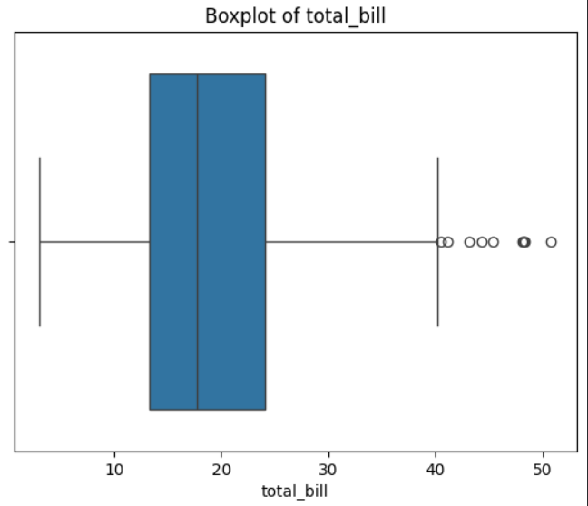
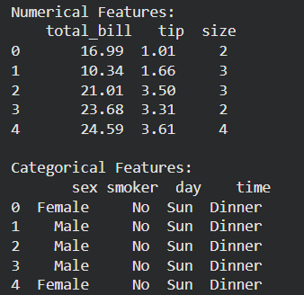

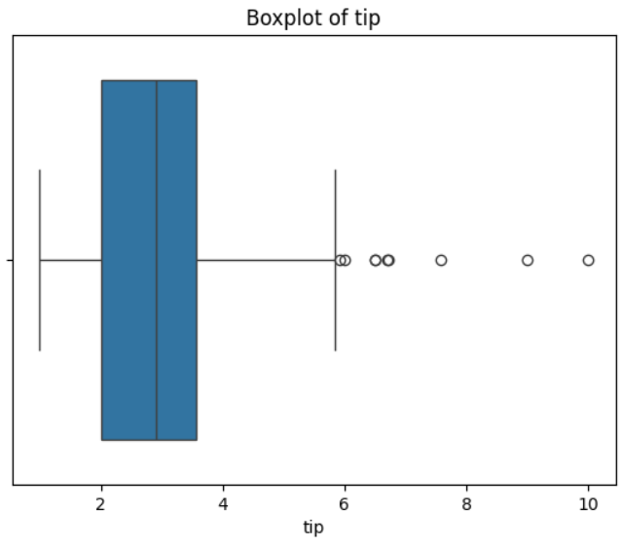
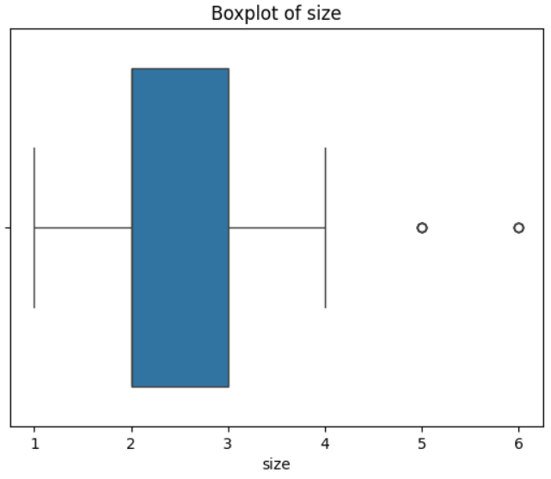

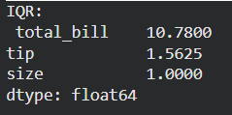

Observation and Result Analysis:

a. Statistics of the dataset

Common statistical measures:

Mean – average value of data

Median – middle value when data is sorted

Mode – most frequent value

Standard Deviation – measure of spread of data

Variance – square of standard deviation

Minimum & Maximum values

Range – difference between max and min

These statistics help in understanding distribution, central tendency, and variability of the dataset.

b. IQR and Outliers

Interquartile Range (IQR)

IQR measures the spread of the middle 50% of data.

$$IQR=Q3-Q1$$

Where:

Q1 = First Quartile (25th percentile)

Q3 = Third Quartile (75th percentile)

Outliers

Outliers are data values that are very far from most other values.

Outliers are detected using:

Lower limit = Q1 − 1.5 × IQR

Upper limit = Q3 + 1.5 × IQR

Any value outside this range is considered an outlier.

Outliers may affect accuracy of ML models, so they are often removed or treated before training.

Post Lab Exercise:

Which is a better mean of replacing the missing value-mean, median or mode?

It depends on the type of data:

Mean → best when data is normally distributed and has no outliers

Median → best when data has outliers or skewed distribution

Mode → best for categorical data

Generally, median is preferred because it is less affected by extreme values.

b. How IQR range helps to understand the nature of the distribution of the data?

IQR shows the spread of the middle 50% of the data.

Small IQR → data values are close together (low variability)

Large IQR → data values are widely spread (high variability)

Helps detect outliers

Helps understand whether data is skewed or consistent

Useful for robust analysis because it ignores extreme values

c. Which are the ways to replace the categorical data to the numerical ones?

Common encoding methods:

Label Encoding – assigns unique number to each category

Example: Red=0, Blue=1, Green=2

One-Hot Encoding – creates separate binary columns for each category

Example: Red → (1,0,0)

Ordinal Encoding – used when categories have order

Example: Low=1, Medium=2, High=3

Binary Encoding – converts categories into binary numbers

Frequency Encoding – replaces category with frequency of occurrence

